**Test Report for X2CT-GAN model**

1. **Model introduction**

The model proposed a novel method to reconstruct CT from two orthogonal X-Ray images using the generative adversarial network (GAN). A specially designed generator network is exploited to increase data dimension from 2D (X-Rays) to 3D (CT), which has not been addressed in previous research works. The model is tested on LIDC data that are used in our experiments, which may help validate the method as well as several baselines.

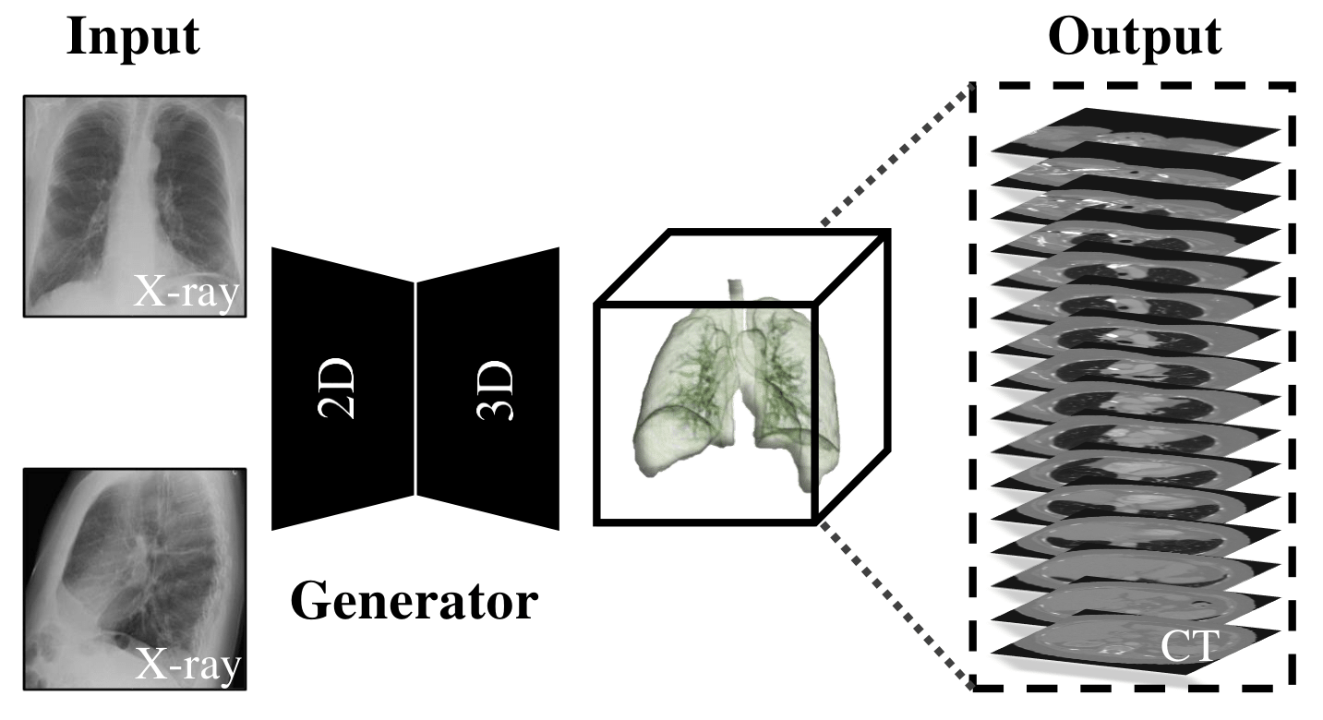

1. **Dataset discreption**

The whole dataset contains 1380 high revolution CT X-ray images:

* Data format: Hierarchical Data Format (HDF), .h5
* Training dataset size: 916 images
* Testing dataset size: 464 images

1. **Model regraining & testing result**

* Model type: X2CT-GAN *(2 orthogonal X-ray images with GAN training architecture)*
* Total epoch: 100
* Total step per epoch: 229 *(25% of total traning dataset)*
* Batch_size: 10
* Retrain configuration: 1 node, 4 GPU *(consistent with the paper)*
* Estimated training period: 15 hour
* Result comperation:

|  |  |  |  |  |
| --- | --- | --- | --- | --- |
| **Model type: X2CT-GAN** | | | | |
| **Metrics** | | **Paper** | **Retrain result** | **Throughput** |
| PSNR | PSNR_3d | 26.19 | 26.2364324 | 29.612069 (images per min) |
| PSNR_1 | - | 28.956451 |
| PSNR_2 | - | 36.0586452 |
| PSNR_3 | - | 27.0350486 |
| PSNR_avg | - | 30.6833816 |
| SSMI | SSMI_avg | 0.656 | 0.6562784 |
| SSMI_1 | - | 0.6515034 |
| SSMI_2 | - | 0.6662555 |
| SSMI_3 | - | 0.6510762 |

*Note: There is only two of the total metrics result in the paper, such as PSNR_3D and SSMI_avg. As a result of our model retrain, we are able to get all the metrics result including per is shown above. Results from PSNR_1 to PSNR_3 indicate the Peak Signal to Noice Rate on projection conparation in 3 dementions, respectively. So as SSMI_1 to SSMI_3.*